【Tuition Assistance Program for Spring Semester AY2024】
Request for Bank Transfer
To Meiji University,
When selected as a recipient for Meiji University Tuition Assistance (Reduction) Program, I request Meiji University to transfer the financial aid to the following bank account. I certify the receipt of financial aid upon completion of the bank transfer
 | ＜Acquisition of Bank Account＞ Have you acquired a bank account in Japan? (as of date of submission)
Yes → Paste copies of your bankbook to the field below and submit this document.
My account status is “Non-resident” because I have been in Japan less than 6 months.
I have already changed my account status “Resident” at bank account.
No → Choose the reason why from below and submit this document.
I still haven’t entered Japan
I have already entered Japan but do not have a residence card.
My application is under review by the bank →enclose the receipt 預り証 (兼引換証) that the bank issues
【Paste photocopies of the bankbook here】
Please attach photocopies of both the cover page and the first facing pages. (E-bankbook is also allowed)
Information listed below must be included, and the copy must be strong enough to read clearly
【Name of bank, branch, type of account, account number, and name of account holder (in both kanji/alphabet and katakana)】
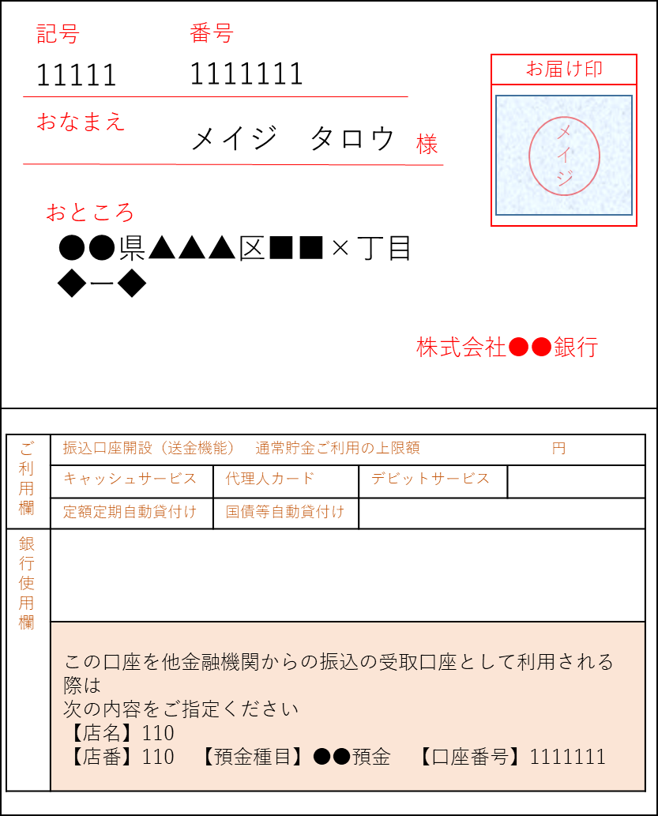*Changing bankbooks after submission is basically not allowed.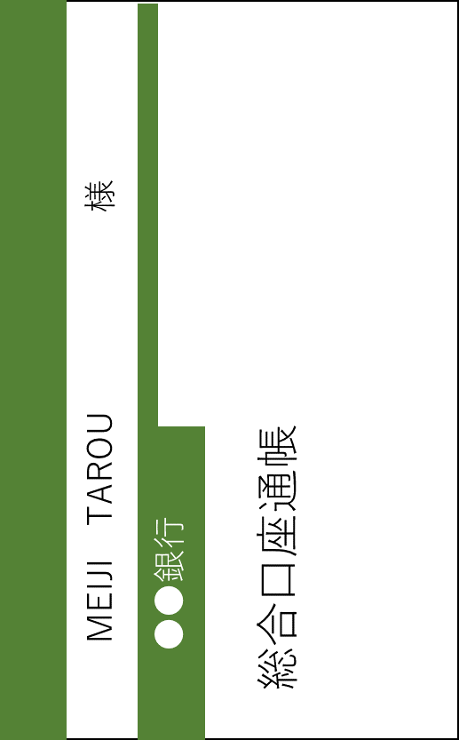
(Example)
First paste the cover page, and then paste the facing pages.
Be careful not to overlap on the account holder’s name of the cover page.

 |  | Affiliation | School of
 |  |  | Grad. School of |  |  |  | Course
 |  |  | Student ID
 |  | Name |  |  |  | Signature
Personal information on this form is used only for the bank transfer regarding financial aid.

