Green-Lean Manufacturing Improvement and Simulation in a Manufacturing Company

本テンプレートの構成をご参考の上、テンプレート内に既に入っているダミータイトルやダミー文章等をご自身の論文内容に書き換えてご提出ください。

**※提出前に本コメントを削除してください。**

*Shao Wei Koh 1 and Kuan Yew Wong 1*

¹ Faculty of Mechanical Engineering, Universiti Teknologi Malaysia, 81310 Johor Bahru, Johor, Malaysia

**Abstract** – *The production of manufacturing waste, as stated by Taiichi Ohno, can occur without notice. Hence, lean principles are essential to implement in order to solve this issue. Apart from this, countries all around the world also pay attention to the environmental aspect of manufacturing industries. Hence, there are three objectives for this research. The first objective is to value-stream map the operation of a manufacturing company in terms of waste and carbon emissions. Secondly, to develop a future value-stream map that would reduce indirect carbon emissions and WIP for the manufacturing company. Lastly, to evaluate the effectiveness of the future value-stream map through discrete-event simulation. This study will start by generating the current green VSM and analyzing the manufacturing waste and CO2 emissions from the production line. Afterward, using the Witness simulation to simulate the current and improved processes, then compared their effectiveness. The method that will be used is the lean principle, which is a pull system. Based on the study, the model with a pull system will generate less work in progress and carbon dioxide emissions as compared to the push system.*

# Keywords: Green-VSM; Carbon Emission; Work in Progress; Pull System; Discrete event simulation

**1. Introduction**

Lean manufacturing, also known as the Toyota Production System (TPS), has been widespread among companies in developed countries since the 1980s to address fierce competition [1]. Lean manufacturing focuses on the removal of waste and non-value added activities with the aid of lean tools such as Value Stream Mapping (VSM) [2].

In recent years, environmental issues have been highlighted globally. Manufacturing industries play a major role in achieving green and sustainable manufacturing by integrating environmental, social, and economic considerations into their operations. Hence, applying the combination of “Lean and Green” strategies has become the standard for many manufacturing companies. This approach not only allows them to care for the environment but also reduces costs and risks and improves their brand image at the same time [3]. The organization can achieve simultaneous benefits such as enhanced operational efficiency, reduced waste emissions, and conservation of resources.

A Green Value Stream Mapping (Green VSM) is a visual representation of an organization’s processes with the goal of reducing environmental impact. Apart from encompassing all steps from raw materials to final product delivery, Green VSM evaluates each step from an environmental standpoint. It serves as an effective tool for a company to make a decision based on lean and environmental aspects [4].

Finally, a simulator is encouraged for use in research. This is because simulators represent real processes. They are cost effective by eliminating physical items, provide immediate feedback, and offer time efficiency by generating long-term results in seconds. The simulator that will be used in this research is Witness.

**2. Methodology**

*2.1 Green Value Stream Map (Green-VSM)*

The first step of this research is to map out the current state of the manufacturing process into a traditional VSM. Then, perform a time study to acquire the cycle time of each process. Until now, the traditional VSM has been formed. Then, convert to green VSM by inserting the carbon dioxide emission value from forklifts and machines. The carbon dioxide emitted when generating electricity in Malaysia is 409.14 grams per kilowatt hour, while burning LPG by forklift will emit 0.23kg of carbon dioxide per kg of LPG. The LPG and electrical consumption are collected from the research company. Next, analyze the green VSM to find waste and CO2 emissions. Based on the Green VSM for the current state of the company, high WIP and CO2 emissions had been detected. The cause of these wastes is the pull system used in the company. So, a pull system had been suggested to improve the current system. This is because a pull system’s main idea is to start an action only if the next station is free. Thus, no WIP will accumulate between the stations.

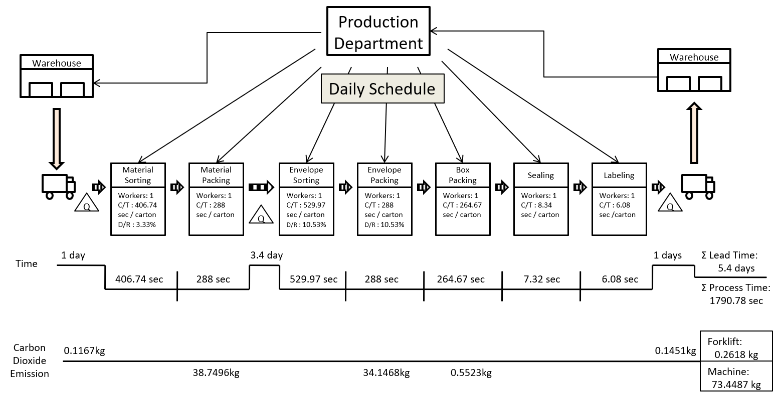

Figure 1: The Green-VSM for current state process.

*2.2 WITNESS Simulation*

In order to examine the effectiveness of the suggested pull system, a simulation application named Witness will be used to simulate the results of the current and proposed processes. This is to compare the output of the current and proposed processes. Before comparing, the simulation model has to be verified and validated in order to show the most accurate result. Finally, record the simulated output, discuss it, and draw a conclusion from the research.

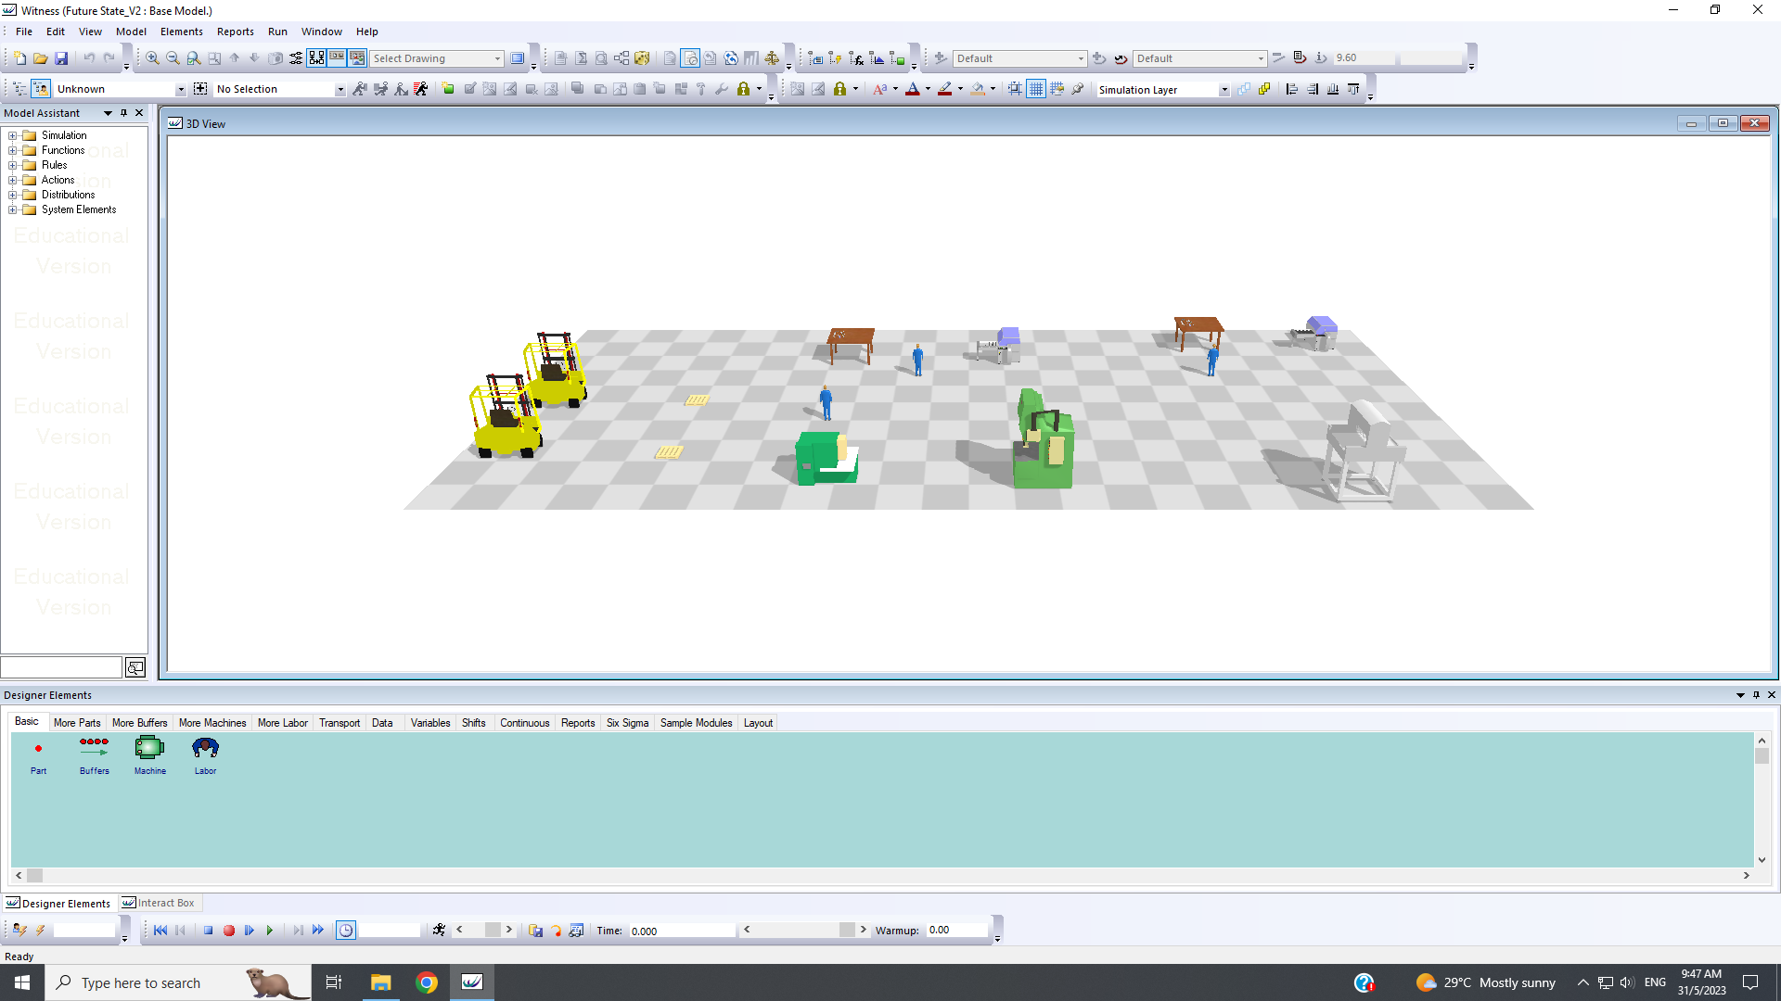

Figure 2: The simulation model in 3D.

**3. Results and Discussions**

*3.1 Output*

|  |  |  |
| --- | --- | --- |
| Week | Cumulative Output, carton | |
| Current | Future |
| 1 | 309 | 309 |
| 2 | 618 | 618 |
| 3 | 928 | 928 |
| 4 | 1237 | 1237 |

Table 1. The cumulative output by week in carton for current and future state processes.

*3.2 Carbon Dioxide Emission*

|  |  |  |
| --- | --- | --- |
| Week | CO₂ Emitted, kg | |
| Current | Future |
| 1 | 260.20 | 243.00 |
| 2 | 520.47 | 486.20 |
| 3 | 780.73 | 729.30 |
| 4 | 1040.90 | 972.53 |

Table 2. Total CO₂ emitted from forklift and machine for current and future state processes.

**4. Conclusion**

In conclusion, a pull system will reduce the number of works in progress and carbon dioxide emissions in a production line. However, the number of outputs remains the same for the current and future state models. Thus, the lean principle of using a pull system is very effective in saving inventory costs, protecting the environment, and meeting the customer’s requirements / demand at the same time. So, implementing a pull system rather than a push system in a manufacturing company is strongly recommended.

**Acknowledgement**

The author would like to grip this opportunity to thanks the company for the information and data support in this research.

**References**

[1] Hartini, S., Ciptomulyono, U., Anityasari, M., & Pudjotomo, D. (2018).

Sustainable-value stream mapping to evaluate sustainability performance: case study in an Indonesian furniture company. *MATEC Web of Conferences*, *154*, 01055. https://doi.org/10.1051/matecconf/201815401055

[2] Colim, A., Morgado, R., Carneiro, P., Costa, N., Faria, C., Sousa, N., Rocha, L. A., & Arezes, P. (2021). Lean Manufacturing and Ergonomics Integration: Defining Productivity and Wellbeing Indicators in a Human–Robot Workstation. *Sustainability*, *13*(4), 1931. https://doi.org/10.3390/su13041931

[3] Fercoq, A., Lamouri, S., Carbone, V., Lelievre, A., and Lemieux, A. A. (2013) Combining Lean and Green in Manufacturing: A Model of Waste Management. *7th IFAC Conference on Manufacturing Modelling, Management, and Control.* 19-21 June. Saint Petersburg, Russia, 117-122.

[4] Sultan, F. A., Routroy, S., & Thakur, M. (2021). A simulation-based performance investigation of downstream operations in the Indian Surimi supply chain using environmental value stream mapping. *Journal of Cleaner Production*, *286*, 125389. https://doi.org/10.1016/j.jclepro.2020.125389

[5] Fairuz, S. M. C., Sulaiman, M. Y., Lim, C. H., Mat, S., Ali, B., Saadatian, O., Ruslan, M. H., Salleh, E., & Sopian, K. (2013). Long term strategy for electricity generation in Peninsular Malaysia – Analysis of cost and carbon footprint using MESSAGE. *Energy Policy*, *62*, 493–502. https://doi.org/10.1016/j.enpol.2013.08.005

[6] Johnson, E. (2008). Disagreement over carbon footprints: A comparison of electric and LPG forklifts. *Energy Policy*, *36*(4), 1569–1573. https://doi.org/10.1016/j.enpol.2008.01.014