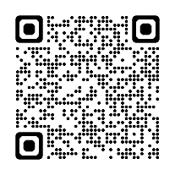
SGJS Study Abroad Encouragement Subsidy
Bankbook Copy Attachment Sheet

【Applicant Information】
Student ID：1910 Full Name：

【Checklist】 Before submitting, please confirm all of the following items and check (☒) each box.
The copy of the bankbook is the exact same bank account registered in the online application.
The bank account is the applicant’s own ordinary savings account (普通預金) in Japan.
The attached document contains all items (1–7) listed under 【Required Information】.

～PLEASE ATTACH HERE～
※It is acceptable for the documents to extend beyond this box, as long as all required items can be confirmed.
【Required Information】 *Ensure that all items from 1 through 7 are included.
1. Bank Name 5. Account Number (7 digits (6 digits depending on the bank)
2. Branch Name 6. Account Holder’s Name (Not needed if in katakana only)
3. Branch Code (3 digits) 7. Account Holder’s Name in katakana
4. Type of Account (Only savings accounts (普通預金口座) are accepted)

【Documents to Attach】
This will be used to verify the bank account information for the subsidy payment. To ensure you can receive the subsidy, scan it in high resolution so all required information is clearly legible.
◆ If you have a physical bankbook, attach the following two items:
① A copy of the bankbook cover
② A copy of the first two-page spread of the bankbook
◆ If you do not have a physical bankbook, attach a copy of the web/eco bankbook (online banking screen) that shows your bank account information.
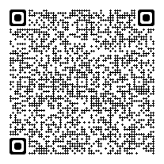
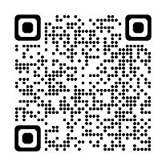
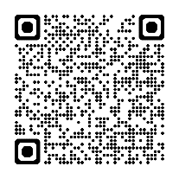
※Examples of the web screen（as of March 2026）*Only available in Japanese.
SMBC Bank
Web 通帳より「口座番号連絡書」を表示
→ Link
Mizuho Bank
みずほダイレクトログイン後、「口座番号連絡書」を表示
→ Link
MUFG Bank
アプリ、または、インターネットバンキングにログイン後、通帳表紙
イメージを表示
→ Link

Japan Post Bank
「通帳イメージの表示」に
ついてを確認
→ Link
For other banks, if no paper bankbook is available, check the institution’s website etc. and submit a Web/Eco bankbook containing all 【Required Information】.
Resona Bank / Saitama Resona Bank
マイゲートにログイン後の画面のコピーを提出
→ Link

